Bank Loan Report SQL Queries
Total Loan Applications
SELECT COUNT(ID) AS total_loan_applications
FROM bank_loan_data;
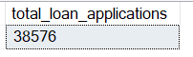
MTD Loan Applications
SELECT COUNT(id) AS MTD_loan_applications
FROM bank_loan_data
WHERE MONTH(issue_date) = 12 and YEAR(issue_date) = 2021;
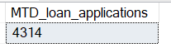
SELECT COUNT(id) AS MTD_loan_applications
FROM bank_loan_data
WHERE MONTH(issue_date) = 11 and YEAR(issue_date) = 2021;
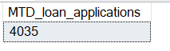
MoM Loan Applications
WITH PMTD AS(
SELECT COUNT(id) AS MTD_loan_applications
FROM bank_loan_data
WHERE MONTH(issue_date) = 11 and YEAR(issue_date) = 2021
),
CMTD AS (
SELECT COUNT(id) AS MTD_loan_applications
FROM bank_loan_data
WHERE MONTH(issue_date) = 12 and YEAR(issue_date) = 2021
)
SELECT (CMTD.MTD_loan_applications - PMTD.MTD_loan_applications)/cast((PMTD.MTD_loan_applications) as decimal(10,2)) AS MoM
FROM CMTD,PMTD;
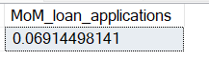
Total Funded Amount
SELECT SUM(loan_amount) as total_funded_amount
FROM bank_loan_data;
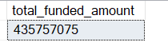
MTD Funded Amount
SELECT SUM(loan_amount) as MTD_funded_amount
FROM bank_loan_data
WHERE MONTH(issue_date) = 12 and YEAR(issue_date)=2021;
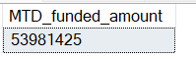
SELECT SUM(loan_amount) as MTD_funded_amount
FROM bank_loan_data
WHERE MONTH(issue_date) = 11 and YEAR(issue_date)=2021;
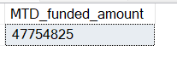
Total Amount Received
SELECT SUM(total_payment) as total_amount_received
FROM bank_loan_data;
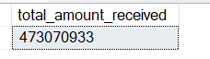
MTD Total Amount Received
SELECT SUM(total_payment) as MTD_amount_received
FROM bank_loan_data
WHERE MONTH(issue_date)=12 and YEAR(issue_date)=2021;
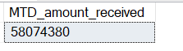
SELECT SUM(total_payment) as MTD_amount_received
FROM bank_loan_data
WHERE MONTH(issue_date)=11 and YEAR(issue_date)=2021;
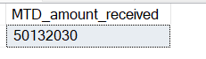
Average Interest Rate
SELECT AVG(int_rate)*100 AS Average_interest_rate
FROM bank_loan_data;
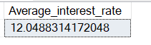
MTD Average Interest Rate
SELECT ROUND(AVG(int_rate),4)*100 AS MTD_Average_interest_rateFROM bank_loan_data
WHERE MONTH(issue_date)= 12 and YEAR(issue_date)=2021;
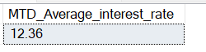
Average DTI(Debt to Income Ratio)
SELECT ROUND(AVG(dti),4)*100 as Average_dti_ratio
FROM bank_loan_data;
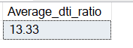
MTD Average DTI(Debt to Income Ratio)
SELECT ROUND(AVG(dti),4)*100 as MTD_Average_dti_ratio
FROM bank_loan_data
WHERE MONTH(issue_date)=12 AND YEAR(ISSUE_DATE)=2021;
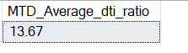
Good Loan Application Percentage
SELECT (COUNT(CASE WHEN loan_status = 'Fully Paid' OR loan_status = 'Current' THEN id END)*100)/COUNT(id) AS good_loan_percentage
FROM bank_loan_data;
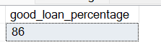
Good Loan Applications
SELECT COUNT(ID) as good_loan_applications
FROM bank_loan_data
WHERE loan_status = 'Fully Paid' or loan_status = 'Current';
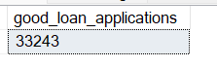
Good Loan Funded Amount
SELECT SUM(loan_amount) as good_loan_funded_amount
FROM bank_loan_data
WHERE loan_status in ('Fully Paid', 'Current');
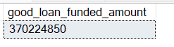
Good Loan Total Received Amount
SELECT SUM(total_payment) as good_loan_received_amount
FROM bank_loan_data
WHERE loan_status in ('Fully Paid', 'Current');
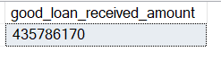
Bad Loan Application Percentage
SELECT COUNT(case when loan_status = 'Charged Off' then id end)*100/count(id) as bad_loan_application_percentage
FROM bank_loan_data;
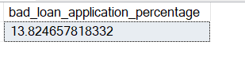
Bad Loan Applications
SELECT COUNT(ID) as bad_loan_applications
FROM bank_loan_data
WHERE loan_status = 'Charged Off';
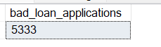
Bad Loan Funded Amount
SELECT SUM(loan_amount) as bad_loan_funded_amount
FROM bank_loan_data
WHERE loan_status not in ('Fully Paid', 'Current');
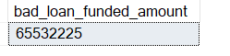
Bad Loan Received Amount
SELECT SUM(total_payment) as bad_loan_received_amount
FROM bank_loan_data
WHERE loan_status not in ('Fully Paid', 'Current');
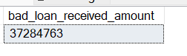
Loan Status Grid View
SELECT loan_status,
count(id) as "Total Loan Applications",
sum(loan_amount) as "Total Funded Amount",
sum(total_payment) as "Total Received Amount",
round(avg(int_rate)*100,2) as "Average Interest Rate",
round(avg(dti)*100,2) as "Average DTI"
FROM bank_loan_data
GROUP BY loan_status;
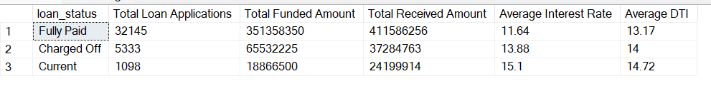
SELECT loan_status,
sum(loan_amount) as MTD_Funded_Amount,
sum(total_payment) as MTD_Received_Amount
FROM bank_loan_data
WHERE MONTH(ISSUE_DATE) = 12
GROUP BY loan_status;
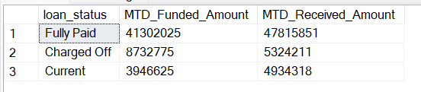
---- DASHBOARD 2
Monthly Trends by Issue Date (Line Chart)
SELECT MONTH(issue_date) AS Month_number,DATENAME(MONTH,issue_date) AS Month,
COUNT(id) AS Total_Loan_Applications,
SUM(loan_amount) AS Total_Funded_Amount,
SUM(total_payment) AS Total_Received_Amount
FROM bank_loan_data
GROUP BY MONTH(issue_date),DATENAME(MONTH,issue_date)
ORDER BY MONTH(issue_date);
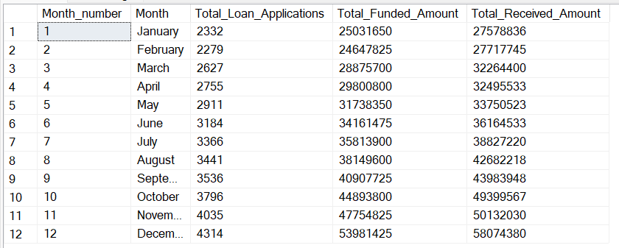
Regional Analysis by State (Filled Map)
SELECT address_state,
COUNT(id) as Total_Loan_Applications,SUM(loan_amount) AS Total_Funded_Amount,SUM(total_payment) AS Total_Received_Amount
FROM bank_loan_data
GROUP BY address_state
ORDER BY COUNT(id) DESC;
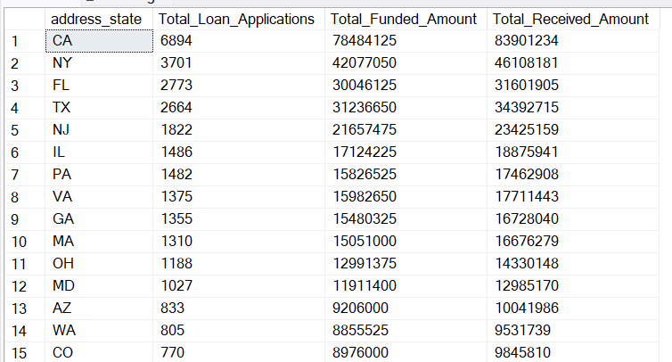
Loan Term Analysis (Donut Chart)
SELECT term,
COUNT(id) as Total_Loan_Applications,
SUM(loan_amount) AS Total_Funded_Amount,
SUM(total_payment) AS Total_Received_Amount
FROM bank_loan_data
GROUP BY term
ORDER BY term;
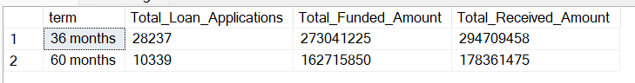
Employee Length Analysis (Bar Chart)
SELECT emp_length,
COUNT(id) as Total_Loan_Applications,
SUM(loan_amount) AS Total_Funded_Amount,
SUM(total_payment) AS Total_Received_Amount
FROM bank_loan_data
GROUP BY emp_length
ORDER BY COUNT(id) DESC;
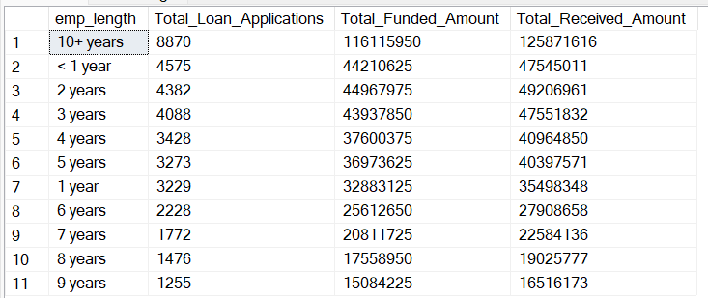
Loan Purpose Breakdown (Bar Chart)
SELECT purpose,
COUNT(id) as Total_Loan_Applications,
SUM(loan_amount) AS Total_Funded_Amount,
SUM(total_payment) AS Total_Received_Amount
FROM bank_loan_data
GROUP BY purpose
ORDER BY COUNT(id) DESC;
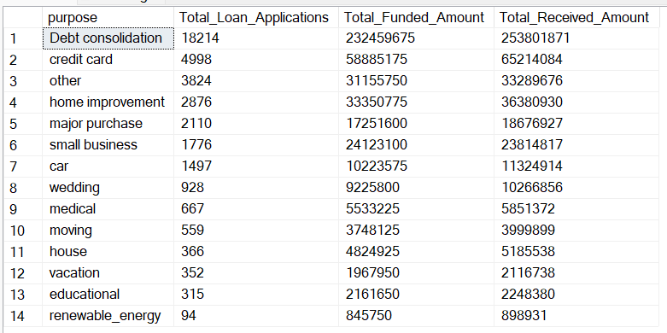
Home Ownership Analysis (Tree Map)
SELECT home_ownership,
COUNT(id) as Total_Loan_Applications,
SUM(loan_amount) AS Total_Funded_Amount,
SUM(total_payment) AS Total_Received_Amount
FROM bank_loan_data
GROUP BY home_ownership
ORDER BY COUNT(id) DESC;

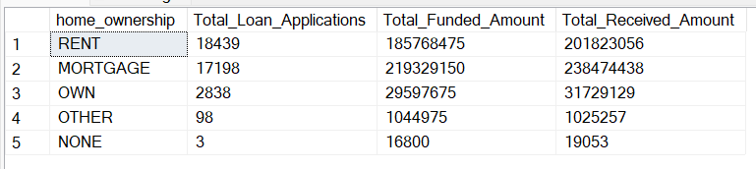

BANK LOAN POWER BI MEASURES
- Date Table = CALENDAR(MIN(bank_loan_data[issue_date]),MAX(bank_loan_data[issue_date]))
- Month = FORMAT('Date Table'[Date],"mmm")
- Total_loan_applications = COUNT(bank_loan_data[id])
- MTD Loan Applications = TOTALMTD([Total_loan_applications],'Date Table'[Date])
- PMTD Loan Applications = TOTALMTD([Total_loan_applications],DATEADD('Date Table'[Date],-1,MONTH))
- MoM Loan Applications = DIVIDE(([MTD Loan Applications]-[PMTD Loan Applications]),[PMTD Loan Applications])
- MTD Funded Amount = TOTALMTD(SUM(bank_loan_data[loan_amount]),'Date Table'[Date])
- PMTD Funded Amount = CALCULATE([Total Funded Amount],DATESMTD(DATEADD('Date Table'[Date],-1,MONTH)))
- MoM Funded Amount = DIVIDE(([MTD Funded Amount]-[PMTD Funded Amount]),[PMTD Funded Amount])
- Total Amount Received = SUM(bank_loan_data[total_payment])
- MTD Amount Received = TOTALMTD([Total Amount Received],'Date Table'[Date])
- PMTD Amount Received = TOTALMTD([Total Amount Received],DATEADD('Date Table'[Date],-1,MONTH))
- MoM Amount Received = DIVIDE(([MTD Amount Received]-[PMTD Amount Received]),[PMTD Amount Received])
- Average Interest Rate = AVERAGE(bank_loan_data[int_rate])
- MTD Average Interest Rate = TOTALMTD([Average Interest Rate],'Date Table'[Date])
- PMTD Average Interest Rate = TOTALMTD([Average Interest Rate],DATEADD('Date Table'[Date],-1,MONTH))
- MoM Average Interest Rate = divide(([MTD Average Interest Rate]-[PMTD Average Interest Rate]),[PMTD Average Interest Rate])
- Average DTI Ratio = AVERAGE(bank_loan_data[dti])
- MTD Average DTI = TOTALMTD([Average DTI Ratio],'Date Table'[Date])
- PMTD Average DTI = CALCULATE(AVERAGE(bank_loan_data[dti]),DATESMTD(DATEADD('Date Table'[Date],-1,MONTH)))
- MoM Average DTI = DIVIDE(([MTD Average DTI]-[PMTD Average DTI]),[PMTD Average DTI])
- Good Loan Applications = CALCULATE(count(bank_loan_data[id]), (bank_loan_data[loan_status]="Fully Paid" || bank_loan_data[loan_status]="Current"))
- Good Loan Percentage = DIVIDE([Good Loan Applications],[Total_loan_applications])
- Good Loan Funded Amount = CALCULATE([Total Funded Amount],bank_loan_data[loan_status]="Fully Paid" || bank_loan_data[loan_status]= "Current")
- Good Loan Received Amount = CALCULATE([Total Amount Received], bank_loan_data[loan_status]="Fully Paid" || bank_loan_data[loan_status]="Current")
- Bad Loan Applications = CALCULATE([Total_loan_applications],bank_loan_data[loan_status]="Charged Off")
- Bad Loan Percentage = DIVIDE([Bad Loan Applications],[Total_loan_applications])
- Bad Loan Funded Amount = CALCULATE([Total Funded Amount],bank_loan_data[loan_status]="Charged Off")
- Bad Loan Received Amount = CALCULATE([Total Amount Received],bank_loan_data[loan_status]="Charged Off")

